EX NO:07
DATE:
GLOBAL SUPERSTORE SALES TREND FORECASTING

AIM: To create a sales trend forecasting visualization in Tableau using the Global Superstore 2016 dataset to predict future product sales trends over the next six quarters.
Use the global superstore 2016 to create a visualization predicting the precise future trends of the sale of the product over 6 quarters.
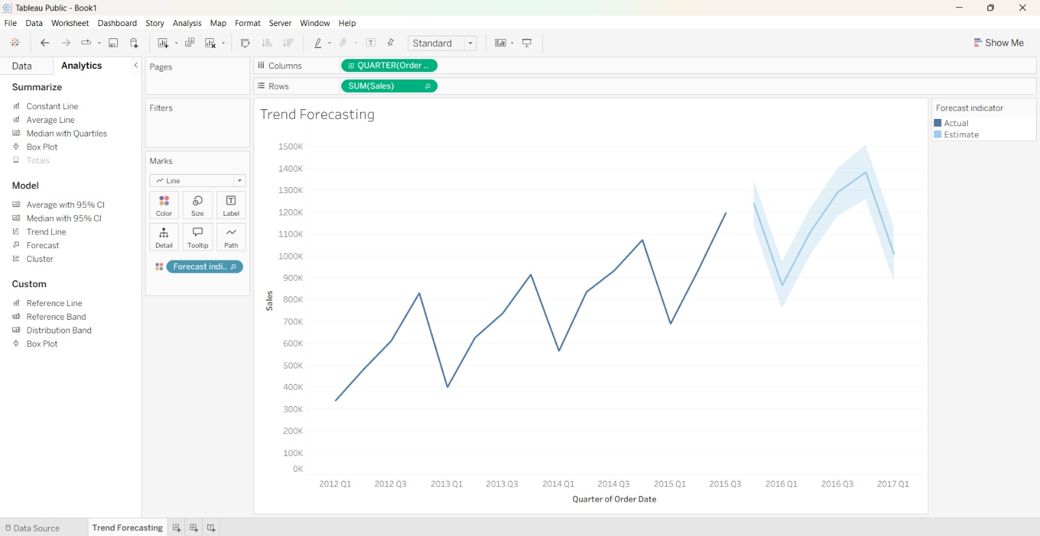
INTERPRETATION
The sales trend forecasting visualization helps analyze historical product sales and predict sales patterns for the next six quarters. It identifies possible increases or decreases in sales and helps understand future sales trends. These forecasts support better business planning, inventory management, and decision-making.

